
Stamford Community Orchard Group
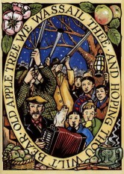
Wassail Wassail

Sat 3rd Jan
4.30 pm

Stamford Community Orchard
(end of Christ Church Close, off Green Lane - /// fills.notice.lions)

Join us in this noisy old English custom, sing to the trees and bang your old saucepans to bring a good harvest of apples. With seasonal songs, cider, apple juice, brazier etc…..

Bring saucepans, wooden spoons, torches, lanterns, warm clothing, sparklers and ribbons
Parking - ///wizard.tender.fresh

